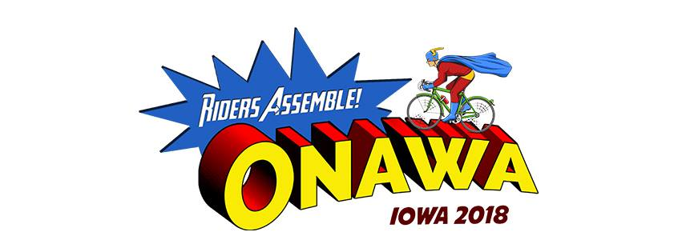
50/50 grant match from RAGBRAI 2018 proceeds in the amount of $20,000.
- Match up to a maximum of $2,500.
- Required to be betterment of the Onawa community.
- Projects need to be completed by August 1, 2019.
- Application deadline January 1, 2019.
- Winners will be announced February 1, 2019.
- Funds will be distributed when the project is complete.
- Non-profit organizations only.

Grant information needed:
- Describe project.
- How it will better the community.
- When project will be completed.
- Total cost, attach estimate.

Please send all grant information to:
Onawa Chamber of Commerce
707 Iowa Ave
Onawa, IA 51040

